**Step Algorithm Process and Information**

Jerry Sun

Contents

1 The tendency analysis of the step patterns 2

1.1 The natural walking pattern: (refer to references) 2

1.2 Comparing the accelerations of different axes( X ,Y and Z axis) 3

2 The features of X, Y and Z axis accelerations 6

3 The conditions for judging the steps 9

3.1 The analysis of there axes accelerations (refer to references) 9

3.2 Peak of The acceleration Change 10

3.3 Dynamic Threshold Judgement 12

# Analysis of Step Patterns

As everyone knows, during our daily lives there are a lot of different walking or movement patterns: seating, standing, sleeping, walking, cycling, running and so on. First and foremost, let us check over all of those patterns and briefly analyze how the accelerometer works for each.

## Natural Walking Pattern: (refer to references)

When a pedestrian is walking on the road, the accelerometer will divide the motion acceleration by three directions, as we can see in the picture below: *Vertical Direction*, *Forward Direction* and *Side Direction*, which can be also called: X, Y and Z Axis.

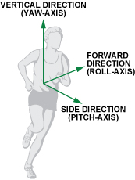

The two photos below show the change state of the vertical acceleration and forward acceleration in one cycle of a step.

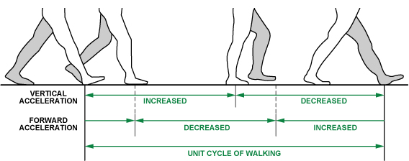

***(***This Picture is from online)***

## Comparing the Accelerations of Different Axes

There are some charts below which show X, Y and Z axis acceleration data separately from the iPhone 6s accelerometer. Each chart shows five states of movement in 30s at 50 Hz*.* Details are shown in the table below*:*

|  |
| --- |
| Accelerometer Data Record |
| Record Date: 16/10/2017 |
| **Frequency: 50 Hz** |
| Time Interval Total: 2.5 Minutes |
| First 30s: Static |
| Second 30s: Walking in pocket |
| Third 30s: Walking in hand |
| Fourth 30s: Running in pocket |
| Fifth 30s: Running in hand |

The data recorded from the X-axis acceleration of iPhone 6S accelerometer over a period of 2.5 minutes.

The data record of the Y-axis acceleration of iPhone 6S accelerometer over a period of 2.5 minutes.

The data record of the Z-axis acceleration of iPhone 6S accelerometer over a period of 2.5 minutes.

From these three charts, we can see the wave clearly. When the movement is static in the first 30s, there is no change in any axis it is always nearly 0. And in the next 60s (in the walking state), there is a slowly change, but in last 60s, there is a dramatic fluctuation in the readings. *What we can surmise here is that the acceleration totally fluctuates with the* ***amplitude of movement.***

Even with the relationship between accelerations and amplitude of movement, we cannot actually use one axis to calculate the steps as pedestrians can walk or run in different directions. Therefore, the fluctuations of three axes accelerations are always changing. So how can we catch or summarize a correct regulation using the data of iPhone 6s accelerometer data? This will be explained in next chapter.

# Features of X, Y and Z Axis Accelerations

## Total Acceleration Concept

There is a concept, *total acceleration*, that will be explained in following paragraphs. Total acceleration can be computed using the equation below.

***(*** This format is from online )***

So what does this equation do? Exactly it merges the accelerations of three axes values, X, Y and Z, of iPhone 6s accelerometer, to one value, which can represent or reflect the amplitude ***no matter which directions people walk or run to.***

There is a chart below, which shows the wave pattern of Axyz value, which is calculated from the last X, Y and Z axis data above in five states above of movement per 30s in 50 Hz. (Five states in 2.5 minutes data, First 30s: static, Second 30s: Walking iPhone in pocket, Third 30s:Walking iPhone 6s in hand, Fourth 30s: Running iPhone 6s in pocket, Fifth 30s: Running iPhone 6s in hand) .

From this chart, we can see a very clear variation tendency and it is clear to distinguish every 30s the person walks in different states. For example, for the third 30s, the person is walking and put the phone in hand, and then they start to run after 30s, and the variation of data is more dramatic as the amplitude of the movement increases.

## Comparison of Total Acceleration with Three Axes

The chart below compares the separate three axes accelerations with the merged one, so the blue line almost represent the overall trend of the other three lines data: X, Y and Z axis acceleration data.

# Conditions for Judging Steps

This step is carried out after getting the amplitude variation tendency chart above.

## Common Sense of Walking Speed

We assume that people can run as rapidly as five steps per second and walk as slowly as one step every two seconds. Thus, the interval between two valid steps is defined as being in the time window [0.2 s to 2.0 s]; all steps with intervals outside the time window should be discarded. According this rule, we record the acceleration data from iPhone 6s in 50Hz Frequency, one value per 0.02 ms. Since the valid step period is between 0.2 to 2 s, one step is represented by approximately 10 to 100 data samples.

Basing on this time window [0.2 s to 2.0 s], two features: Peak Values Of The Acceleration and Threshold Judgement, can be extracted from the charts above. Following these two standards, we can record the number of steps through the Axzy data.

## Analysis of Three Axes Accelerations (refer to references just for introduction)

In this section, there are some pictures which show the analysis of the vertical and horizontal acceleration of the foot during one step of walking. Here, the signal pattern of walking behaviors is obtained. As we can see in the two pictures below, where a , h , g means horizontal acceleration, vertical acceleration and gravity force, respectively.

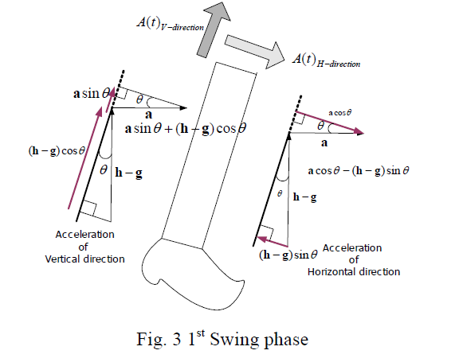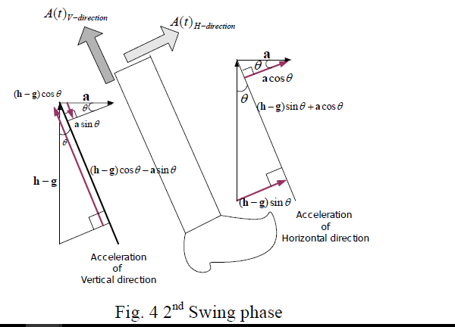

The strides of the walker are different according to the varying human parameters. The stride depends on several factors such as walking velocity, step frequency and the height of the walker etc.

The horizontal direction acceleration and vertical direction acceleration during the swing phase is denoted in equation below, where θ(t) is inclination angle of the leg at time t.

1509825475(1)

## Peak Values of the Acceleration

Considering the posture of people walking, we can get a standard of the acceleration change. Combining the formulae above and some pictures below showing three phases of a step, we can find there must have some peak values and bottom values of Axyz data, which are shown in the following chart.

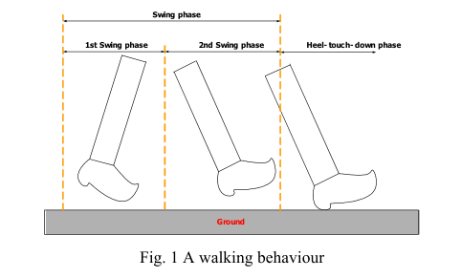

***(***This Picture is from online)***

This chart shows the total acceleration wave of walking in pocket during 2 seconds from the 2.5 minutes above chart. From the diagram, we can mark some positive and negative peak values, and there are some rules for judging whether peak values are available or not:

Rule 1: Before the positive peak value, there must have two increase changes happened before and one decrease happened after, so we can see the picture below (a part of the last picture above), which shows two black values increase continuously before the first red peak value and one purple value after decrease dramatically. And the follow red positive peak value should be discarded because of having only one increase value before it.

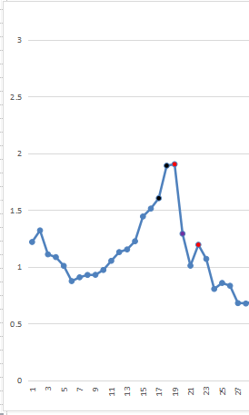

Rule 2: The negative peak is very simple to judge, which includes one increase value after it and one decrease before. After following these two rules, we can discard several invalid data, which are replaced with a normal blue color from red color, comparing with the first one to finding the difference.

## Dynamic Threshold Judgement

### The Format of the Threshold

After extracting some alternative positive and negative peaks, we can see there are still some obvious invalid values shown in the chart above, so how can we discard those invalid values? Here, we introduce a ***threshold value***, only when the positive peak value is larger than the threshold, can it be considered as a valid peak value. How to decide the exact value of the threshold of acceleration is a key point.

The threshold value = (Peak_value + Bottom_value)/2

From the chart above, there is trend of threshold value, we can compare the peak values with the threshold value to filter the invalid data.

### The Dynamic Threshold Concept

As already discussed, different patterns of movement have different amplitudes of acceleration Axyz data. We should update the threshold in real time. There is a strategy in which we can calculate an average of four threshold values. There are some charts below, comparing the walking pattern with running pattern.